**Well Being: Methylene Blue**

Another wonder supplement?

|  |  |
| --- | --- |
| rom: | **Robert W Malone MD from "Who is Robert Malone"** <rwmalonemd@substack.com> |
| reply-to: | Robert W Malone MD from Who is Robert Malone <reply+2ln7hm&doii8&&a178d263c0d23694d97e46ebd373f33d7f6ae30faad4ea8b24d12c3106e598d9@mg1.substack.com> |
| to: | fchase@gmail.com |
| date: | Feb 17, 2025, 1:45 PM |
| subject: | Well Being: Methylene Blue |

[[https://substackcdn.com/image/fetch/w_36,h_36,c_fill,f_auto,q_auto:good,fl_progressive:steep/https%3A%2F%2Fbucketeer-e05bbc84-baa3-437e-9518-adb32be77984.s3.amazonaws.com%2Fpublic%2Fimages%2F0eb501a5-9fd2-4174-9231-6d6a73139db9_400x400.jpeg](https://substack.com/@rwmalonemd)](https://substack.com/@rwmalonemd)

[Robert W Malone MD, MS](https://substack.com/@rwmalonemd)

Feb 17, 2025

∙ Paid

Heart(Like)=233

[Comments(Questions)=51](https://www.malone.news/p/well-being-methylene-blue/comments)

Shared=31

[[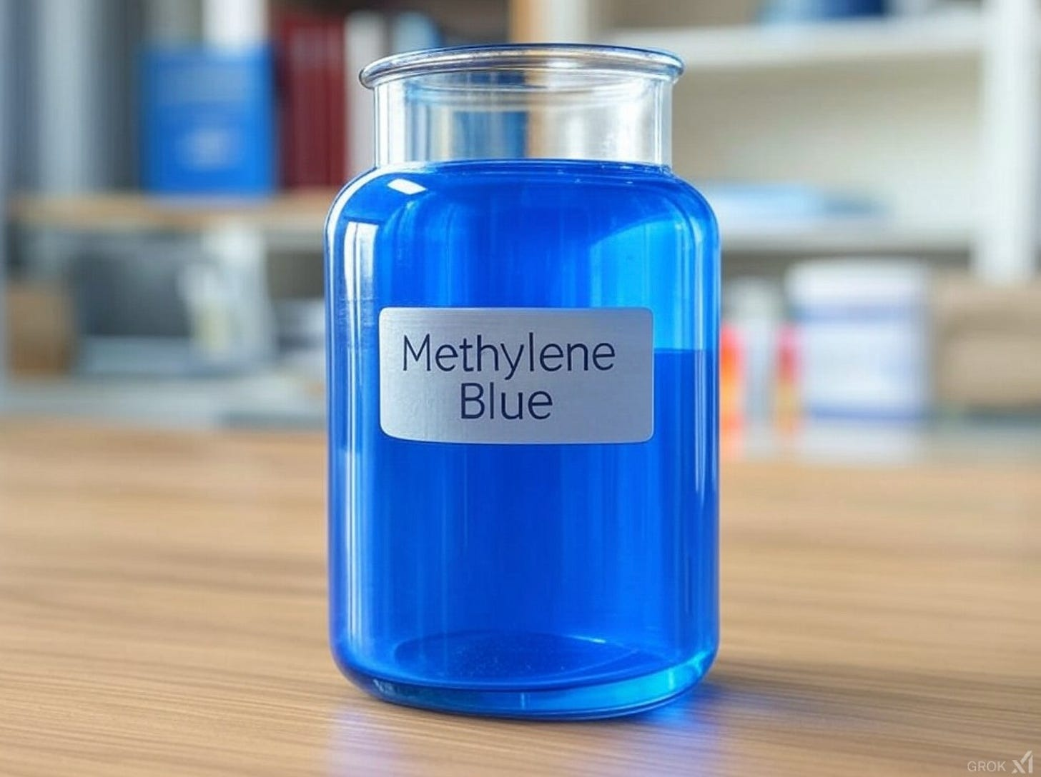](https://substackcdn.com/image/fetch/f_auto,q_auto:good,fl_progressive:steep/https%3A%2F%2Fsubstack-post-media.s3.amazonaws.com%2Fpublic%2Fimages%2Fb7abf2f1-4c72-4ae3-b6bc-de659490fd0a_1518x1134.png)](https://substackcdn.com/image/fetch/f_auto,q_auto:good,fl_progressive:steep/https%3A%2F%2Fsubstack-post-media.s3.amazonaws.com%2Fpublic%2Fimages%2Fb7abf2f1-4c72-4ae3-b6bc-de659490fd0a_1518x1134.png" \t "_blank)

**Bio-hacking is a DIY method to achieve optimal health.**

Bio-hacking is a broad concept that involves optimizing one's body and mind through various techniques, technologies, and lifestyle changes. It combines biology, technology, and self-experimentation to enhance human performance and well-being.

Suppose one endorses the view that westernized medicine, government-sponsored science, and the peer-reviewed literature have been coopted by cooperation between big pharma, biotech, academia, and big government. In other words, the biopharmaceutical/government/academic industrial complex. In that case, one is left with no alternative other than to explore other ideas, technologies, and solutions to optimize health. Sometimes this is referred to as integrative medicine when done in partnership with a medical practitioner, but when you are experimenting on yourself, this is bio-hacking. I suppose that when I treated myself with famotidine after I was infected with the original strain of SARS-CoV-2 in February 2020, I was essentially bio-hacking my COVID treatment to avoid going to the local hospital and being put on remdesivir and a ventilator.

This is particularly true as we age. The metaphor I like to use is keeping an older car in good running shape. Parts are repaired and replaced. Sometimes those parts may have to be custom made, recalls have replaced some original parts, and newer lubricants may also increase the life of the car. Generally, the vehicle slowly morphs into something that is functionally a little different than the original, but may become even more functional than the original production model. Keeping such a vehicle at its peak performance takes extra work, maintenance, and repairs. But in the end, as the beloved and carefully nurtured vehicle evolves, it may become a classic.

**The best doctor you will ever have is looking at you in the mirror.**

The human body breaks down over time. Our organs, joints, and ligaments wear out, particularly if not well cared for. The gut absorbs micro nutrients, minerals, and vitamins less efficiently. By carefully maintaining our bodies at peak performance, learning to use both natural and chemical supplements, vitamins, hormones, foods, exercise and even medical devices (such as lens replacements), implants, stem cell and regenerative medical procedures, prosthetic joints, etc., people can maintain a better quality of life and even extend longevity.

Is this for everyone? No. But if one chooses to try to bio-hack their body, there is a growing body of evidence that shows the results can be truly phenomenal. In many ways, the pioneers of bio-hacking have been the body builders, who are constantly searching for new ways to achieve their objectives. You could make the case that the new Secretary of Health and Human Services, RFKjr, is one of those body builders. Take a moment to think about that. The current HHS director is a body builder. What extraordinary times we live in.

Jill and I both use a lot of supplements, vitamins, as well as bio-identical hormone replacement therapy. We constantly research new ways to improve our health. We will carefully add a new supplement or treatment (such as infrared red light therapy) and then analyze the results. We experiment with our diet. Yep, self-experiment… and the results have been incredible energy levels, better cognitive function, a lowered metabolic age, significant weight loss, improved cardiac function, metabolic health, a (continued) excellent sex life, and most likely, a longer lifespan (time will tell…). If I hadn’t bio-hacked myself starting about three years ago, after my vaccine injury (Moderna dose #2, a documented bad batch), I am not sure I would still be alive.

So, despite the scare tactics of mainstream media, self-experimentation or bio-hacking is genuinely beneficial to improving health, fitness, and the aging process.

The fitness community, particularly the weight lifting community, has contributed significantly to the modern bio-hacking ethos. Today, bio-hacking encompasses a wide range of practices beyond just physical fitness and includes:

1. DIY Biology: Experiments and modifications at the genetic and cellular level (1).
2. Nutrigenomics: Personalized nutrition based on genetic testing (2).
3. Wearable Technology: Using devices to track and optimize various health metrics.
4. Supplements and Nootropics: Experimenting with substances to enhance cognitive and physical performance (3).
5. Environmental Modifications: Using techniques like infrared saunas, hyperbaric oxygen or cold exposure to influence bodily functions

Are there risks? Yes.

Are all of these self-experiments clinically proven? No.

However, with careful analysis, research, and understanding that a conservative approach is always best - particularly when adding any new element to improving health- I believe the benefits of using a biohacking approach to health are significant and tangible. Whether or not this is true will become clearer over time, and losing weight is the starting point. But I am informed and willing to take the personal risk.

As an aside, from a libertarian frame of reference, my point of view is that people should have the right to equality of health opportunity, and the focus should not be on equality of health outcomes (as opposed to what modern “public health” strives for- the greatest good for greatest number). If POTUS wants to eat McDonalds and drink Coca-cola, it is his right to do so. The burden should be to ensure that true and accurate information about the risks of diet and various health-related decisions (and treatments including “vaccines”) is available to citizens, so that they can act autonomously with informed consent. I advocate that physicians function as health partners and consultants, not as paternalistic enforcers of HMO, insurance plan, and Federal mandates. Personal sovereignty, autonomy, and commitment to the principle of subsidiarity.

**Methylene Blue (MB)**

When I first read in mainstream media about HHS Secretary Kennedy being videotaped on a plane ingesting methylene blue, I was gobsmacked. I used methylene blue for various histopathological techniques in pathology and as a professor/researcher years ago, so I didn’t think of it as anything but a dye or pigment.

I decided to go deeper into the use of methylene blue as a supplement, and was blown away by the information I found. I became convinced that this compound, at the appropriate dose, can provide multiple benefits to human health.

**Methylene Blue and cellular energy**

Mitochondria, the powerhouses of our cells, play a crucial role in regulating cellular metabolism and homeostasis. As we age, mitochondrial function progressively declines, leading to impaired oxidative phosphorylation activity, increased oxidative damage, and changes in mitochondrial morphology, dynamics, and biogenesis. Mitochondrial dysfunction is one of the essential elements of the aging process. Poor mitochondrial health is linked to the development of many age-related pathologies including metabolic syndrome, neurodegenerative disorders, cardiovascular diseases and cancer (4).

Methylene blue (MB) was developed as a textile dye in 1876, but it has since found numerous uses in medicine, biology, and chemistry. Its role as a medicinal is well established, and it has been used to treat methemoglobinemia, malaria, and neurological conditions such as Alzheimer’s. MB’s role in improving mitochondrial efficiency has become well established in the scientific literature. It increases cellular oxygen consumption, enhances oxidative phosphorylation, and promotes mitochondrial activity while reducing anaerobic metabolism.

Methylene blue (MB) can help reduce fatigue and improve overall energy levels by enhancing mitochondrial activity, including ATP production. It has been shown to have significant potential in repairing mitochondrial damage and improving mitochondrial function, and it is believed that it may increase longevity. Numerous animal and cell-based studies indicate that its ability to affect aging may be significant. This includes it acting as an antioxidant, protecting cells from oxidative damage, and potentially reducing the risk of chronic disease.

**Methylene Blue and cognitive function**

**Cognitive Function:** MB appears to enhance cognitive function and memory by improving mitochondrial efficiency and brain oxygenation. It crosses the blood-brain barrier and acts as an antioxidant, protecting cells from oxidative damage. Its antioxidant properties can mitigate oxidative stress and inflammation within the brain (5, 6).

***The unique auto-oxidizing property of methylene blue and its pleiotropic effects on a number of tissue oxidases explain its potent neuroprotective effects at low doses.***

***The evidence reviewed supports a mechanistic role of low-dose methylene blue as a promising and safe intervention for improving memory and for the treatment of acute and chronic conditions characterized by increased oxidative stress, neurodegeneration and memory impairment (7).***

Improved cognitive function appears to be the main reason people take MB as a low dose supplement.

**Methylene Blue as an antimicrobial**

MB has shown effectiveness against various pathogens, including bacteria, fungi, and parasites.

Methylene blue was used to treat malaria until newer, more effective antimalarial drugs replaced its use. However, research continues into methylene blue malaria treatment as an adjunct treatment, especially in drug-resistant malaria strains.

**Likewise, methylene blue is an excellent**adjunct **therapy for those with chronic** Lyme disease, an infection caused by Borrelia bacteria transmitted through tick bites. It has been shown to inhibit the growth and proliferation of Borrelia bacteria, providing a complementary approach to standard antibiotic treatments (8).

Methylene blue also seems to act as an antiparasitic by producing reactive oxygen species that harm the internal structures of parasites (5).

**Methylene Blue and Cancer**

Although still in research and development phase, methylene blue (MB) has emerged as a promising agent in cancer treatment, offering potential benefits through various mechanisms and therapeutic approaches. Recent research has highlighted its efficacy in multiple cancer types and its ability to enhance existing treatment modalities.

Methylene blue exerts its anticancer effects through several key mechanisms:

1. **Mitochondrial Targeting**: MB disrupts the electron transport chain in cancer cell mitochondria, leading to reduced ATP production and ultimately causing apoptosis (9).
2. **Generation of Reactive Oxygen Species (ROS)**: When exposed to light of a suitable wavelength, MB generates ROS, which can directly kill cancer cells (10).
3. **Metabolic Alteration**: MB can cause cancer cells to switch from glycolysis to oxidative phosphorylation, making them more dependent on oxygen and vulnerable to treatment (11).

**Methylene Blue and Mouth Pain.**

Many studies have been conducted have shown that MB can be used successfully for mouth pain, including burning mouth syndrome.

**Dosing and route of oral delivery for optimal health**

(paid subscriber-restricted content below)

Only pharmaceutical-grade (USP Grade) MB should be considered.

Only products without Formaldehyde should be considered.

Preferably Third-Party Tested, made in USA.

**Proper Dosage:**

**Low doses of MB (0.5 to 4 mg) are the preferred dosing.** Please note that many people exhibit jitteriness at the higher dose. For first timers, consider starting at the lower scale of dosing.

Higher doses should only be used for specific therapeutic goals under medical supervision. Chronic high doses may accumulate in tissues, leading to unknown long-term effects.

**Oral delivery: capsules or sublingual?**

Both pharmaceutical-grade capsules and sublingual formulations are readily available.

The choice between capsules and sublingual forms depends on individual preferences and needs. Capsules offer convenience and avoid staining, while sublingual forms may provide faster onset of effects. Both forms can be effective.

**Considerations**

* Slower absorption: Capsules may have a slower onset of action compared to sublingual forms due to the need for digestion.
* Capsules offer convenience and avoid staining, while sublingual forms may provide faster onset of effects.
* Both forms can be effective, with capsules showing high bioavailability (72.3% ± 23.9%) in studies (12).
* Sublingual forms may have higher bioavailability as they bypass first-pass metabolism in the liver. But a comparison of the two forms has not been conducted.
* Sublingual or liquid formulations may taste unpleasant and stain the teeth and mouth.
* Liquid formulations will stain countertops, clothing, etc.
* When using liquid forms, carefully check your dosing calculations. Concentrations vary between brands and formulations.

**Skin Creams:**

Many products with MB are now formulated as skin creams. However, the effectiveness of such products is difficult to determine. One peer-reviewed paper used an in-vitro approach, showing that MB effectively stimulated skin fibroblast proliferation and delayed cellular aging (17).

**Intravenous Infusions:**

I do not recommend IV infusions, unless treating a specific condition. High doses of MB should be administered under a physician’s care.

**Side Effects and potential risks**

**Dosing dangers:** Low doses of MB can be beneficial, but higher doses can be harmful. Chronic high doses may accumulate in tissues, leading to unknown long-term effects.

**Side Effects:** Common side effects include gastrointestinal distress, headaches, jitteriness, and dizziness (13). Decrease the dose or discontinue use, if side effects are observed. Blue-green discoloration of urine is a normal side effect

**Drug Interactions:** MB can interact dangerously with certain medications, particularly SSRIs and SNRIs, potentially leading to serotonin syndrome (14).

**Toxicity Concerns:** At high doses, MB can interfere with mitochondrial function, act as a pro-oxidant, and even be neurotoxic in animal studies.

**Contraindications**

**Glucose-6-phosphate dehydrogenase (G6PD) deficiency**: Methylene blue is contraindicated in patients with G6PD deficiency due to the risk of hemolytic anemia (15).

People with severe hypersensitivity reactions to methylene blue or other thiazine dye allergies should not take MB. To reiterate, it is always safest to begin any dosing regime at the lowest end of the scale (0.5 mg).

**Serotonin syndrome risk: Methylene blue may cause serious or fatal serotonergic syndrome when used in combination with serotonergic drugs. Caution is advised for patients taking SSRIs, TCAs, or MAOIs (14, 15).**

**Pregnancy: Methylene blue can harm unborn babies. Pregnant women or those who may become pregnant should use effective birth control while taking this medication (16).**

**Kidney problems**: Elderly patients with kidney issues may require dose adjustments (16).

**Hemoglobin M**: Methylene blue is ineffective in patients with hemoglobin M, an abnormal hemoglobin molecule.

**References and recommended reading:**

1. Do It Yourself Biology (Wiki) https://en.wikipedia.org/wiki/Do-it-yourself\_biology
2. What is biohacking – and can you actually hack your health? https://www.the-independent.com/health-and-fitness/what-is-biohacking-b2611675.html
3. The Truth on Biohacking and How It Might Make You a Better Runner https://www.runnersworld.com/training/a45125567/biohacking/
4. The Mitochondrial Basis of Aging and Age-Related Disorders https://pmc.ncbi.nlm.nih.gov/articles/PMC5748716/
5. What Is Methylene Blue? Health Benefits of a Versatile Compound https://advancedivhealth.com/blog/what-is-methylene-blue-health-benefits-of-a-versatile-compound.
6. Exploring Methylene Blue and Its Derivatives in Alzheimer's Treatment: A Comprehensive Review of Randomized Control Trials https://pubmed.ncbi.nlm.nih.gov/38022191/
7. **Neurometabolic mechanisms for memory enhancement and neuroprotection of methylene blue https://pmc.ncbi.nlm.nih.gov/articles/PMC3265679/**
8. **Methylene Blue For Treating Lyme Disease, Bartonella, and Babesia https://projectlyme.org/methylene-blue/**
9. Methylene blue and cancer https://cancercenterforhealing.com/methylene-blue-and-cancer/
10. **Chapter 6: Methylene Blue for Cancer Photodynamic and Photothermal Therapy https://www.worldscientific.com/doi/10.1142/9789811277702\_0006**
11. Methylene Blue for Cancer Therapy https://www.macsenlab.com/blog/methylene-blue-for-cancer-therapy/
12. **High absolute bioavailability of methylene blue given as an aqueous oral formulation https://pubmed.ncbi.nlm.nih.gov/18810398/**
13. **Methylene Blue Benefits in Longevity Medicine https://www.naturemedclinic.com/methylene-blue-benefits-in-longevity-medicine/**
14. **FDA Drug Safety Communication: Serious CNS reactions possible when methylene blue is given to patients taking certain psychiatric medications https://www.fda.gov/drugs/drug-safety-and-availability/fda-drug-safety-communication-serious-cns-reactions-possible-when-methylene-blue-given-patients**
15. Methylene blue in drugs https://www.drugs.com/monograph/methylene-blue.html
16. **Methylene blue (Intravenous) https://www.drugs.com/cons/methylene-blue.html**
17. **Anti-Aging Potentials of Methylene Blue for Human Skin Longevity https://pubmed.ncbi.nlm.nih.gov/28559565/**

Malone News is a reader-supported publication. To receive new posts and support our work, consider becoming a free or paid subscriber. We are deeply grateful to the decentralized network of paid subscribers that enables us to continue doing what we do to support freedom.

Subscribed

Thanks for reading Who is Robert Malone! This post is public so feel free to share it.

[Share](https://www.malone.news/p/well-being-methylene-blue?utm_source=substack&utm_medium=email&utm_content=share&action=share&token=eyJ1c2VyX2lkIjoyMjk3ODczNiwicG9zdF9pZCI6MTU3Mjg3MDgyLCJpYXQiOjE3Mzk4MjM1NzQsImV4cCI6MTc0MjQxNTU3NCwiaXNzIjoicHViLTU4MzIwMCIsInN1YiI6InBvc3QtcmVhY3Rpb24ifQ.gcxo1mo15_uG9DxvYhJJ_K_XA_cVWK1MbWc9p575tD8)

Malone News is a reader-supported publication. To support our work, consider giving a gift subscription. We are deeply grateful to the decentralized network of paid and gifted subscribers that enable us to continue doing what we do to support freedom.

[Give a gift subscription](https://www.malone.news/subscribe?&gift=true)

[[https://substackcdn.com/image/fetch/w_32,h_32,c_fill,f_auto,q_auto:good,fl_progressive:steep/https%3A%2F%2Fsubstack-post-media.s3.amazonaws.com%2Fpublic%2Fimages%2F5230c563-a9bc-4b92-bdeb-5afbae5027fa_144x144.png](https://substack.com/profile/47520721-lasederick-deshawn-mcdougle)](https://substack.com/profile/47520721-lasederick-deshawn-mcdougle)

[[https://substackcdn.com/image/fetch/w_32,h_32,c_fill,f_auto,q_auto:good,fl_progressive:steep/https%3A%2F%2Fbucketeer-e05bbc84-baa3-437e-9518-adb32be77984.s3.amazonaws.com%2Fpublic%2Fimages%2Feeba24c4-890f-4117-84ff-b2114f496fb9_4032x3024.jpeg](https://substack.com/profile/49481559-laura)](https://substack.com/profile/49481559-laura)

[[https://substackcdn.com/image/fetch/w_32,h_32,c_fill,f_auto,q_auto:good,fl_progressive:steep/https%3A%2F%2Fsubstack-post-media.s3.amazonaws.com%2Fpublic%2Fimages%2F04792e67-faf1-4e19-84a2-deb466c9a39b_1024x763.jpeg](https://substack.com/profile/85718424-john-bernasconi)](https://substack.com/profile/85718424-john-bernasconi)

[[https://substackcdn.com/image/fetch/w_32,h_32,c_fill,f_auto,q_auto:good,fl_progressive:steep/https%3A%2F%2Fsubstack-post-media.s3.amazonaws.com%2Fpublic%2Fimages%2F949a354f-4b48-4ab7-9e5b-71e030298749_418x430.jpeg](https://substack.com/profile/171871891-belle)](https://substack.com/profile/171871891-belle)

[[https://substackcdn.com/image/fetch/w_32,h_32,c_fill,f_auto,q_auto:good,fl_progressive:steep/https%3A%2F%2Fsubstack-post-media.s3.amazonaws.com%2Fpublic%2Fimages%2F38d70f8f-6a2b-42d9-83b7-79f5b9841aaa_1281x1281.jpeg](https://substack.com/profile/35949413-mary-lou-tringali-phd)](https://substack.com/profile/35949413-mary-lou-tringali-phd)

233 Likes∙

[31 Restacks](https://substack.com/note/p-157287082/restacks?utm_source=substack&utm_content=facepile-restacks)